Christmas Breakfast with Santa Claus!
Ho Ho Ho! Santa is taking a road trip to LVFD Firehouse!
Hope to see you there!

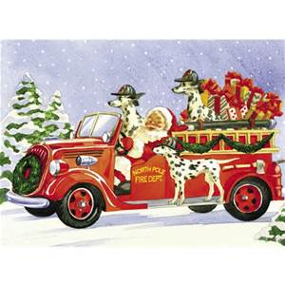
On behalf of the Leonardtown Volunteer Fire Department and the Auxiliary of the Leonardtown Volunteer Fire Department we cordially invite you to come and enjoy an All-You-Can-Eat breakfast with Santa and the volunteers of the Fire Department and Auxiliary.

Date: Sunday, December 13, 2015
Time: 8:00 am to 11:30 am
Place: Leonardtown Volunteer Fire Dept.

Menu: Bacon, Sausage, Scrambled Eggs, Pancakes, Home Fries, Applesauce
Coffee, Tea, Juice and Milk
Cost: Adults $9.00, Seniors $8.00, Children (6-12) $5.00,
5 and under eat free. ****Carry outs available - $8.00 ****

There will be fire truck and sleigh rides available around town for adults and children of all ages! Make sure you get your picture taken with Santa before you leave.
